Project Title



STUDENT NAME1 FAxx-BCE-00
STUDENT NAME2 FAxx-BCE-00
STUDENT NAME3 FAxx-BCE-00
STUDENT NAME4 FAxx-BCE-00

Project Advisor: Dr.
FALL 2025

COMSATS UNIVERSITY ISLAMABAD, LAHORE CAMPUS, PAKISTAN

PROJECT ID |  |  |  |  | NUMBER OF MEMBERS
TITLE
SUPERVISOR NAME |  |  | Engr. Moazzam Ali Sahi

MEMBER NAME | REG. NO. | EMAIL ADDRESS

CHECKLIST:
Number of pages in this report
I/We have enclosed the soft-copy of this document along-with the codes and scripts created by myself/ourselves | YES / NO
I/We confirm to state that this project is free from any type of plagiarism and misuse of copyrighted material | YES / NO

MEMBERS’ SIGNATURES

Abstract

The abstract is a very brief summary of the report's contents. It should be about half a page long. Somebody unfamiliar with your project should have a good idea of what it's about having read the abstract alone and will know whether it will be of interest to them.
…

Table of contents
1 Introduction 1
2 Literature Review 2
3 Project Design 3
3.1 M 3
3.2 Ar 4
3.3 De 4
3.3.1 5
3.3.2 5
4 Implementation 6
4.1 Development Stages 6
4.1.1 <Component 1> 6
4.1.2 <Component 2> 6
4.2 User Interface 6
4.2.1 <UI Component 1> 6
4.2.2 <UI Component 2> 7
5 Evaluation 8
5.1 Unit Testing 8
5.2 Function Testing 8
5.2.1 Testing Requirements < A, B, C> 8
5.2.2 Testing Requirements < A, B, C> 8
5.3 Results 8
5.3.1 Results of Development Stage 1 8
5.3.2 Results of Development Stage 2 8
5.4 Comparison 8
5.5 Socio-Economic and Environmental Impact of the Project 8
6 Conclusions & Future Work 9
References 10
Appendix A: SUStainable Development Goals Achievement 12
Appendix B: HDL or C Source Code 13
Appendix C: Hardware Schematics 14
Appendix D: List of Components 15
Appendix E: Project Timeline 16

Table of Figures
Figure 2-1 An Example of inserting Figure into your project 2
Figure 3-1 Example Figure for Prototype Application 3
Figure 3-2 Architecture Overview Diagram 4
Figure 4-1 Example Figure for User Interface 7

Introduction
This is one of the most important components of the report. It should begin with a clear statement of what the project is about so that the nature and scope of the project can be understood by a lay reader. It should summarize everything you set out to achieve, provide a clear summary of the project's background, relevance and main contributions. The introduction should set the scene for the project and should provide the reader with a summary of the key things to look out for in the remainder of the report.
- The introduction itself should be largely non-technical.
- It is sometimes useful to state the main objectives of the project as part of the introduction.
- Concentrate on the big issues, e.g. the main questions (scientific or otherwise) that the project sets out to answer.

The main goal of the project is to investigate …

The research includes devising possible improvements in …

The project includes development of hardware to …

The project includes development of software to …

Chapter 2 covers the background material and literature reviewed to understand the intricacies of …

Chapter 3
Chapter 4
Chapter 5 explains ...
Chapter 6

In the end, we briefly present the conclusions from this project and also the possible future improvements and additions for better design/implementation and investigation of <PROJECT NAME>.

Literature Review
The background section of the report should set the project into context by relating it to existing published work which you read at the start of the project when your approach and methods were being considered. There are usually many ways of solving a given problem, and you shouldn't just pick one at random. Describe and evaluate as many alternative approaches as possible.

The background section can be included as part of the introduction but is usually better as a separate chapter, especially if the project involved significant amount of prior research. The published work may be in the form of research papers, articles, text books, technical manuals, or even existing software or hardware of which you have had hands-on experience.

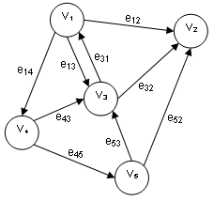
Figure 2-1 An Example of inserting Figure into your project

WARNING: Avoid plagiarism
If you take another person's work as your own and do not cite your sources of information you are being dishonest; in other words you are cheating. When referring to other pieces of work, cite the sources where they are referred to or used, rather than just listing them at the end.

Project Design

M
A very basic prototype was developed … …

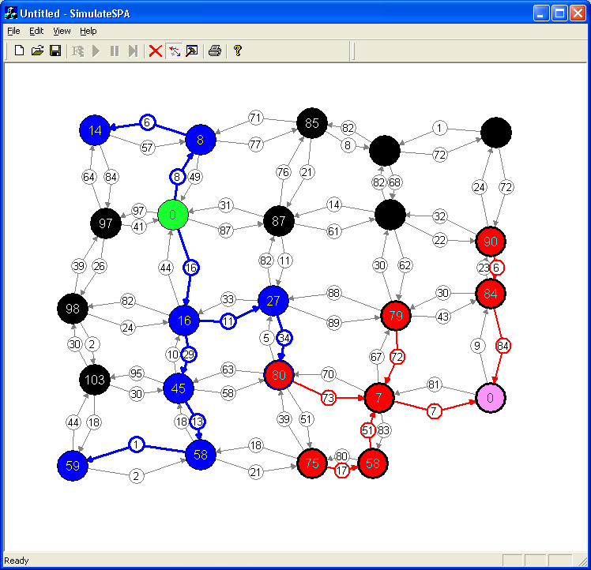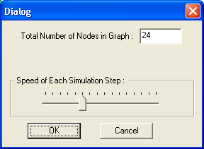
Figure 3-1 Example Figure for Prototype Application
The prototype was helpful in … … … shown in Figure 4-1.

Ar
The design of the intended product is explained graphically with the help of a diagram shown in Figure 4-2. The diagram explains the overall interactions of the modules and their placements.

Network
Path Finder
Interface
Network Decomposer
Path Finder Implementers
Network
Serialization
Network
Editing
Network
Generation
Event
Handlers
Graphical User Interface
(GUI)
Nodes

Objects

Nodes
Links
Nodes

Nodes
Zones
(Partition)
Zones
(Partition)
Zones
(Partitions)
Figure 3-2 Architecture Overview Diagram

De
Following are the modules constituting the product to be developed. Please note that we are documenting only the salient properties and methods of each module to keep the description simple and more readable.

Implementation
We have implemented the suggested design using … …

Development Stages
Following were the

<Component 1>
We have implemented …

<Component 2>
…

User Interface
User Interface is an extremely important consideration for any project that requires human-machine interaction. However, this project doesn’t require human machine interaction and therefore the product runs solely in the background without any user input. Besides this fact, we have introduced an option to display the current status, orientation, and power production from the requested solar panels. The user interface is… …

<UI Component 1>
… … … …
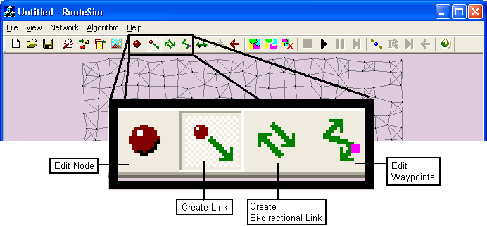
Figure 4-1 Example Figure for User Interface

<UI Component 2>
… … …

Evaluation
This chapter includes the results obtained through the implementation of the suggested design methodology and their detailed discussion …

Unit Testing

Function Testing

Testing Requirements < A, B, C>

Testing Requirements < A, B, C>

Results
Following were the

Results of Development Stage 1
We have implemented …

Results of Development Stage 2

Comparison

Socio-Economic and Environmental Impact of the Project
…

Conclusions & Future Work
In this project, we have investigated and developed … … …

There could be several improvements possible … Some of the ideas for future development is mentioned below:

Idea 1
…

Idea 2
…

Idea 3
…

Future research actions on the Project to enhance its Social and Environmental Impact

References
- Ross Sherlock, Peter Mooney, Adam Winstanley & Jan Husdal, "Shortest Path Computation: A Comparative Analysis", GISRUK pp 91-94, Sheffield, UK, April 2002.

- S. Shekhar, M. Coyle, A. Kohli, Path Computation Algorithms for Advanced Traveller Information Systems, IEEE Computer Society, 1993.

- R. Jacob, M. Marathe and K. Nagel, A Computational Study of Routing Algorithms for Realistic Transportation Networks, invited paper appears in ACM J. Experimental Algorithmics, 4, Article 6, 1999. http://www.jea.acm.org/1999/JacobRouting/

- D. Wagner, T. Willhalm and C. D. Zaroliagis; Geometric Shortest Path Containers; Universit¨ at Karlsruhe, Fakult¨ at f¨ ur Informatik 2004-5, 2004.

- John Taplin, Simulation Models of Traffic Flow, Proceeding of the 34th Annual Conference of the Operational Research Society of New Zealand (ORSNZ'99), Keynote Paper, University of Waikato, Hamilton NZ, December 1999, pp 175-184.

- S. Pallottino e M. G. Scutell`a, Shortest path algorithms in transportation models: classical and innovative aspects, In (P. Marcotte and S. Nguyen, eds.) Equilibrium and Advanced Transportation Modelling, Kluwer (1998) 245-281.

- Andrea Díaz, Verónica Vázquez, G. Wainer. "Vehicle routing in Cell-DEVS models of urban traffic". In Proceedings of European Simulation Simulation. Marseille, France. 2001.

- Rong Zhou and Eric A. Hansen, Breadth-First Heuristic Search , 14th International Conference on Automated Planning and Scheduling (ICAPS-04) Whistler, British Columbia, Canada, 2004.

- Jayadev Misra, A walk over the shortest path: Dijkstra's Algorithm viewed as fixed-point computation. Information Processing Letters. Volume 77, Number 2-4, pp 197-200. February 2001.

- Matthias Schmidt, "Decomposition of a Traffic Flow Model for a Parallel Simulation", Proc. AI, Simulation and Planning in High Autonomy Systems (AIS2000), March 6-8, 2000, Tucson, USA, pp 199-202

- KLD Associates Inc. (last accessed on April, 2004). http://www.kldassociates.com/

- Peytchev E., Bargiela A., Parallel simulation of city traffic using PADSIM, Proceedings of Modelling and Simulation Conference ESM'95, Prague, Eds. M Snorek, M Sujansky, A Verbraeck, June 1995, ISBN 1-56555-080-3, pp. 330-334.

- Oscar Franzese and Shirish Joshi, Traffic Simulation Application to Plan Real-Time Distribution Routes, Proceedings of the 2002 Winter Simulation Conference (WSC), E. Yücesan, C.-H. Chen, J. L. Snowdon, and J. M. Charnes, eds.

- Polly Huang and John Heidemann, Minimizing Routing State for Light-Weight Network Simulation, In Proceedings of the International Symposium on Modeling, Analysis and Simulation of Computer and Telecommunication Systems, p. to appear. Cincinnati, Ohio, USA, IEEE. August, 2001. http://www.isi.edu/~johnh/PAPERS/Huang01b.html

- Yu Jiangsheng, Lecture on Single-Source Shortest Paths, Institute of Computational Linguistics, Peking University, 2003

- Baruch Awerbuch , Bonnie Berger , Lenore Cowen , David Peleg, Near-Linear Time Construction of Sparse Neighborhood Covers, SIAM Journal on Computing, v.28 n.1, p.263-277, Feb. 1999

- Vittorio Astarita, Vincenzo Punzo, Vincenzo Torrieri, Calibration and Comparison Of Simulation Models For Road Network Planning: The Congested Network Of Pozzuoli, 9th Meeting of the Euro Working Group on Transportation, Bari, Italy, June 2002.

- M.Herty And A.Klar, “Modeling, Simulation,And Optimization Of Traffic Flow Networks”, SIAM Journal On Scientific Computing Volume 25, Number 3 Pp. 1066-1087

- Andrew V. Goldberg and Craig Silverstein, Implementation of Dijkstra’s Algorithm Based on Multi-Level Buckets, Technical Report 95-187, NEC Research Institute, Princeton, NJ, 1995

- Ariel Orda and Raphael Rom, "Shortest path and minimum-delay protocols in networks with time-dependent edge-length", Journals of the ACM, Volume 37, Issue 3, pp 607-625, 1990, ISSN:0004-5411

- A. Orda and R. Rom. Shortest-path and minimum-delay algorithms in networks with time-dependent edge-length. Journal of the ACM, 37(3):607--625, 1990.

- Hermann Kaindl and Gerhard Kainz. Bidirectional heuristic search reconsidered. Journal of Artificial Intelligence Research, 7:283--317, 1997.

- D. Wagner, T. Willhalm, C. Zaroliagis. Dynamic shortest path containers. Alberto Marchetti-Spaccamela, Proc. Algorithmic Methods and Models for Optimization of Railways (ATMOS 2003), Volume 92 of Electronic Notes in Theoretical Computer Science, pages 65-84, 2004.

- P. W. Eklund, S. Kirkby, and S. Pollitt, A Dynamic Multi-source Dijkstra’s Algorithm for Vehicle Routing, IEEE Transactions, Proceeding 1996 Australian New Zealand Conference on Intelligent Information Systems, 18-20 November 1996, Adelaide, Australia.

- Öjvind Johansson. Graph decomposition using node labels. PhD thesis, Royal Institute of Technology, Stockholm, 2001.

Appendix A: Sustainable Development Goals Achievement
(Write a detailed description on how your project lie under certain SDGs in the light of your objectives, solutions, and obtained results. Give examples where appropriate)

SDGs | Included/ Not Included | If Included Inclusion Level as: Partial, Average, or Major | Goal (s) of Project that Lie in the SDG | How goal (s) meet the criteria for SDG | Additional Remarks/ Discussions







Appendix B: HDL or C Source Code

Appendix C: Hardware Schematics

Appendix D: List of Components

Appendix E: Project Timeline

DATE

PROJECT ID |  |  |  |  |  | TOTAL NUMBER OF WEEKS IN PLAN
TITLE
No. | STARTING WEEK |  |  | DESCRIPTION OF MILESTONE |  |  | DURATION
1
2
3
4
5
6
7
8
9
10

* You can provide Gantt chart instead of filling this form, if you like

